**Deliverable 2: Literature Review**

**Food Wastage Application: The Sustainable Spoonful**

**By**

**Lea Thumbiran, Lucinda Zachos, Melany Opperman, Santana Bradbury**

A Mini-Dissertation Submitted as a Partial Requirement for the Bachelor Science in Information Technology: Mobile Application and Web Services

In the Faculty of Information Technology, Eduvos

**Supervisors:**

Mr. William Olivier

Ms. Ndai Mapaso

Date: 15 March 2023

1. **Student Details**

|  |  |  |  |
| --- | --- | --- | --- |
| Student Details | Student Number | Telephone Number | Email Address |
| Bradbury, Santana | CNZJB3199 | 071 864 4170 | cnzjb3199@vossie.net |
| Opperman, Melany | 6P6NPJX46 | 074 709 6778 | 6p6npjx46@vossie.net |
| Thumbiran, Lea | LMTPQFTH6 | 079 898 2004 | lmtpqfth6@vossie.net |
| Zachos, Lucinda | Y34VR5C17 | 071 878 3138 | Y34vr5c17@vossie.net |

1. **Supervisor Details**

|  |  |  |
| --- | --- | --- |
| Supervisor Name | Faculty | Email Address |
| Olivier, William | IT | william.olivier@eduvos.com |

Deliverable 2: Table of Contents

Chapter 2: Literature Review 5

2.1 Introduction 5

2.2 Mobile Applications 5

2.2.1 Mobile Applications 1 - Flashfood 5

2.2.2 Mobile Applications 2 – Imperfect Foods 7

2.2.3 Mobile applications 3 – Too Good To Go: End Food Waste 9

2.3 Desktop Applications or Websites 9

2.4 Mobile Application Tools and Technologies 11

2.4.1 Android Studio 11

2.4.2 Java 12

2.4.3 Android SDK 12

2.4.4 SQLite 13

2.4.5 Git / GitHub 13

2.4.6 YouTrack 14

2.4.7 Figma 14

2.4.8 Espresso 14

2.5 Mobile Applications Research and Design Methodologies 14

2.6 Conclusion 18

References 19

**Table of Figures**

Figure 1: Mobile App Development Process 15

Figure 2: Prototyping 16

Figure 3: The Usability Testing Process 16

Figure 4: The Agile Development Process 17

# Literature Review

## Introduction

Food wastage is a significant issue that has a negative impact on the economy, environment and on society. It is estimated that about one-third of all food produced is lost or wasted globally with the biggest contributor to food wastage being consumers. Mobile food-saver applications have become a popular tool in reducing food wastage in recent years. This is due to them providing consumers with a means to reduce food wastage and save money as well.

In this literature review, we will explore the current state of research on mobile food-saver applications as well as their impact on reducing food wastage. We will further examine the features and effectiveness of multiple mobile food-saver applications in different contexts. By incorporating this existing research, we aim to provide a comprehensive understanding of the potential of mobile food-saver applications in addressing the issue of food wastage.

## Mobile Applications

As we embark on this project, we need to acknowledge that there may be competitors in the market. We have managed to identify three similar mobile applications that share our focus but are only available in certain countries, not including South Africa.

**These are:**

* **Flashfood** (Flashfood, 2021).
* **Imperfect Foods** (Imperfect Foods, 2021).
* **Too Good To Go: End Food Waste** (Too Good To Go, 2021).

### Mobile Applications 1 - Flashfood

FlashFood is a mobile application that enables consumers to search for food products that are close to their expiry date and to purchase them at a discounted rate of 50% or more. According to consumers, they have saved at least 50% on their groceries by buying them on this mobile application.

**This mobile application uses the following process (EatSleepBreatheFI, 2021):**

* To utilize this mobile application, users must first create an account. After creating an account, they can then browse through the stores in their area and pick the items that they would like to purchase. They may then pay on the mobile application for the items that they have selected.
* To collect their order, users must go to the stores customer service desk and inform them that they are collecting their Flashfood order.
* Customer service will look up the users’ information on the Flashfood system and ask for a verification of purchase.
* Once the purchase has been verified, the user will be escorted to the Flashfood fridge, which the retailer will unlock and give the user their order.
* It should be noted that the goods that are listed on the mobile application are still fresh and of decent quality.
* The mobile application is limited to stores across Canada but, as of last year, has started expanding their reach into the United States of America.
* Users cannot pay in cash and must pay through the mobile application and therefore must have added their card details to the application.

By comparison, our mobile application will not require the user to link their bank card to pay. Instead, the user will pay at the store that they are collecting from. This way they can pay through cash or card or even purchase more items should they require anything else from the store (Flashfood, 2022).

Our mobile application will instead generate a QR code for the user to scan at the store to qualify for the discount.

#### Technologies used in the existing mobile application.

In the mobile application, Flashfood, they have used a wide variety of tools and technologies to bring their final product together.

**These tools and technologies include but are not limited to (6sense, 2023):**

* **Microsoft Azure** 
  + A Windows Azure cloud-based platform that enables businesses to run critical applications with a higher production price ratio.
  + This is done by running them on the services’ platforms data centres on a pay as you go basis.
* **HTML**
  + HyperText Markup Language (HTML) is the standard markup language for documents that are designed to be displayed in the web browser.
  + HTML can be assisted by CSS (Cascading Style Sheets) and scripting languages.
* **JavaScript** 
  + A programming language used alongside HTML and the Web.
* **Amazon DynamoDB** 
  + A flexible database service that does not use SQL (Structured Query Language).
* **Java** 
  + A programming language that has been implemented and used as a computing platform.
* **Typekit**
  + An online service that offers a subscription-based library of high-quality fonts, which are either used directly on the website or synced using the Adobe Creative Cloud to applications on the subscriber's computer.

### Mobile Applications 2 – Imperfect Foods

Imperfect Foods is a mobile application where fresh produce that is not accepted by stores due to not meeting a certain aesthetical standard is sold at a cheaper rate. In other words, Imperfect Foods delivers superficially imperfect, excess produce at a lower cost. These products are still fresh and perfect to eat but are being sold at a lower rate as their visual appearance is not too appealing.

**This mobile application uses the following process (Chen, C., 2022):**

* Users must first create a profile on the mobile application.
* The mobile application will then ask the user what food items they would like to receive and what food items they would never want to receive. This is done to build a box based on the users' preferences.
* The user can add fresh produce, dairy, meat, seafood, snacks, and a small selection of household and beauty products to their box.
* The user has four days to edit their box of products before it is shipped to the user's house on a specific day.
* Imperfect Foods assigns a delivery day for the user based on their ZIP code as it is easier and better for the environment.
* This means that there will be a shipping fee added to the users’ bill which is usually between $4.99 to $8.99 (or about R90 to R160).
* Imperfect Foods is available in the West South-Central region, Midwest, Northeast, and all along the West Coast of the United States.

In our mobile application, the user must go to the selected store to purchase and collect their chosen food items and it will not be delivered to them. We have decided to exclude this as an option to keep costs low for the user. This would go against our goal of saving users as much as possible when purchasing through our mobile application.

#### Technologies used in the existing mobile application.

In the mobile application, Imperfect Foods, they have used a wide variety of tool and technologies to bring their final product together.

**These tools and technologies include but are not limited to (6sense, 2023):**

* **HTML**
  + HyperText Markup Language (HTML) is the standard markup language for documents that are designed to be displayed in the web browser.
  + HTML can be assisted by CSS (Cascading Style Sheets) and scripting languages.
* **JavaScript**
  + A programming language used alongside HTML and the Web.
* **Java**
  + A programming language that has been implemented and used as a computing platform.
* **RabbitMQ**
  + Open-source message broker software.
* **Moment.js**
  + Open-source JavaScript library for wrapping objects.
* **PostgreSQL**
  + Objected- related database Management system.
* **Optimizely**
  + Experimentation platform used for testing.
* **GitHub**
  + Collaboration tool to help development teams write better code, faster.

### Mobile applications 3 – Too Good To Go: End Food Waste

Too Good To Go is a mobile application that enables users to get meals at a lower cost from restaurants (Tolcheva, S., 2021).

**Features of this mobile application include:**

* Enabling restaurants, food kiosks, and different grocery stores to sell their excess products to make extra income to compensate for food that they would have otherwise thrown away.
* Having a ‘Magic Bag’ on the mobile application where mystery items are added into the box where the cost for it is under $5.
  + This magic bag is the most popular order on the mobile application.
    - The food that gets added to the magic bag varies and the user can either receive sweet or savoury goods. Overall, the magic bag usually consists of three items.

**This mobile application uses the following process:**

* A user creates an account and can view the restaurants around them that are available with the mobile application.
* The user would then make their payment on the mobile application and then go to the store location and pick up their order.

In our mobile application, users will also need to go pick up their order at the selected location, but they cannot pay on the mobile application.

#### Technologies used in the existing mobile applications.

**The main technology used to create this mobile application is:**

* Artificial intelligence (AI) which plays a big role in helping to cut down on food waste. AI may be used to forecast demand, improve supply chain management, and lessen food waste.

## Desktop Applications or Websites

Our mobile application aims to reduce food waste by connecting users with surplus food items at discounted prices. While there are other food waste reduction applications in the market, our application stands out with its unique business model and user-friendly interface.

* One application that is a potential competitor is the application ‘Too Good To Go.’ Like our mobile application, Too Good To Go connects users with surplus food items at discounted prices from local restaurants and grocery stores. However, Too Good To Go operates in multiple countries across Europe and North America, while our mobile application will only operate in South Africa (Too Good To Go, 2023).
* Another similar application is ‘OLIO.’ Unlike Too Good To Go, OLIO allows individuals to share their surplus food items with their local community. The application facilitates peer-to-peer sharing of food, with the aim of reducing food waste at the household level. OLIO operates in multiple countries across Europe and North America (Olio, 2023).
* When it comes to websites, there are a few resources that provide information related to reducing food waste. ‘Love Food Hate Waste’ is a website that provides tips and recipes for reducing food waste, as well as information on food storage and preservation. The website is run by a non-profit organization in the UK and has resources available for users in multiple countries (Love Food Hate Waste, 2019).

**In terms of research related to reducing food waste, there is a growing body of literature on the topic:**

* One recent study published in the journal ‘Sustainability’ analysed customers’ attitudes towards food waste and the use of food waste reduction applications (Salins, M. and Aithal, S., 2022). The study found that consumers were generally positive towards the use of such applications but highlighted the need for greater awareness and education around food waste reduction strategies.
* Another study published in the journal of ‘Cleaner Production’ explored the environmental impacts of food waste reduction interventions and found that interventions focused on reducing food waste at the household level were the most effective in terms of reducing environmental impacts.

In terms of critiques of existing works related to food waste reduction, one common one is that many interventions focus on reducing food waste at a household level, while neglecting the role of larger systemic issues such as supply chain inefficiencies and overproduction.

Additionally, there is a need for greater collaboration between stakeholders in the food system, including producers, retailers, and consumers, to create effective and sustainable solutions for reducing food waste.

Finally, there is a need for more research to be conducted on the long-term impacts and sustainability of food waste reduction interventions, to ensure that they are effective and viable solutions for reducing food waste in the long term.

## Mobile Application Tools and Technologies

**The tools and technologies we plan to use include but are not limited to:**

### Android Studio

The mobile application will be primarily designed using Android studio. This Integrated Development Environment (IDE) is the main IDE for Android application development (Android Developers, 2018).

Android Studio has standout features to enhance our productivity while developing the mobile food-saver application.

**These features include but are not limited to (Android Developers, 2018):**

* A flexible Gradle-based build system.
* A fast and feature-rich emulator.
* A unified environment where development can be done for all Android devices.
* Enabling changes to be made to the live application without the need to restart.
* Easily importing code templates directly into the application.
* GitHub integration for easier task collaboration.
* Supporting a large array of testing tools and frameworks.
* Providing lint tools to catch performance, usability, version compatibility, and other issues.
* C++ support.
* NDK support.
* Providing integrated support for the Google Cloud Platform and Application Engines.

**Why have we chosen to use Android Studio?**

* It is easy to use and provides us with a built-in emulator to test our application during the development process.

### Java

Our language of choice will be Java.

**Java is:**

* A modern Object Orientated programming language (Java.com, 2023).

**Why have we chosen to use Java?**

* Java is a popular programming language that boasts a large online community of developers. This means that should we require support or have an issue during the development phase of our project, there is a wealth of knowledge online to assist us.

**Java versus Kotlin**

* As it stands Java is a more straightforward language but, if necessary, we may switch to using Kotlin for developing this mobile application.

### Android SDK

The Android SDK (Software Development Kit) is a collection of Application Programming Interface (API) libraries and software development tools essential to Android application development (GeeksforGeeks, 2021).

It is regularly updated in response to any Android Studio updates and often includes new features. These features include quality of life updates to both development and debugging.

**Some of the tools included in Android SDK are (GeeksforGeeks, 2021):**

* Android SDK build tool.
* Android Emulator.
* Android SDK platform-tools.
* Android SDK tools.
* Android Debug Bridge.
  + This provides developers with the ability to conduct unit tests and perform automated testing.

In terms of deployment and distribution, the Android SDK also provides the tools necessary to create a signed Android Package Kit (APK) which is required should we wish to list the mobile application on the Google Play Store (Android Developers, 2018).

**Why have we chosen to use the Android SDK?**

* This is an essential tool to mobile development in Android Studio.

### SQLite

Structured Query Language (SQL) Lite is a small, fast, self-contained, high-reliability, full-featured Data Query Language (DQL) database engine (Sqlite.org, 2019).

SQLite is also open-source and free to use.

**Why have we chosen to use SQLite?**

* It is built-in to all mobile phones and is well suited for mobile applications that require local storage.

### Git / GitHub

GitHub is a powerful collaboration tool with unlimited repositories, the best-in-class version control, and a large open-source community (GitHub, 2022).

**Some of the main features of GitHub include:**

* Version control.
  + Makes tracking project changes easier over time.
* Code review.
* Issue Tracking.
  + This includes assigning issues to team members for review.
* Integration.
  + GitHub actions.
    - Assist with automating builds, testing and deployment workflow.

**Why have we chosen to use GitHub?**

* To better help us manage any code changes and provide an easy means of collaboration.
* There is the option of GitHub mobile, so we also have access to our project from any device.

### YouTrack

YouTrack is a project management and collaboration tool developed by IntelliJ under the software company JetBrains.

It can be used to track projects and tasks, use agile boards, plan sprints and releases, create workflows and create and track Gantt Charts (JetBrains, 2022).

We are currently using this tool to track our project and its tasks through a Gantt chart.

### Figma

Figma is a User Experience (UX) web-based design tool used to create interactive wireframes and prototypes. It is a collaboration tool ideal for teams developing mobile applications (Figma, 2023).

**Why have we chosen to use Figma?**

* It is ideal for creating our wireframe concepts.

### Espresso

Espresso was originally created by Google. It is now the go to for Android development testing (Android Developers, 2018).

It easily integrates with Android Studio and allows for both Android native view testing as well as hybrid web-views.

Espresso can be used to write User Interface (UI) tests and it is considered extremely robust.

## Mobile Applications Research and Design Methodologies

Mobile application developers typically use a range of research and design methodologies during the development of their applications.

**These methodologies can include but are not limited to (Ortega 2019):**

* user research
* feature-driven development
* scrum framework
* agile development processes

User research is a key component of mobile application development, as it helps developers to understand the needs and preferences of their target users. This can involve a range of techniques, such as surveys, interviews, and observation, as well as the use of personas and user journeys to guide the development process. User research is particularly important for a mobile application like ours, as it is designed to meet a specific need (reducing food waste) and understanding the motivations and behaviours of users is crucial to developing a mobile application that meets their needs effectively (Orbitum Labs, 2023).

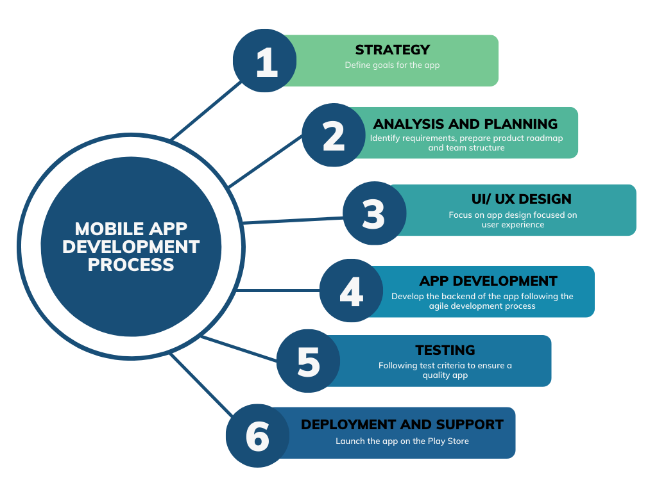

Figure 1: Mobile App Development Process (Hall, R., 2018)

Feature-driven development is an incremental and iterative method to software development. It places emphasis on segmenting the development process into more manageable, smaller components known as features, each of which is independently produced, tested, and integrated into the whole system. Collaboration is a key component of feature-driven development, and the development team and stakeholders are actively involved throughout the process.

(Ling, 2020) Feature-driven development is essential for a mobile application like ours, as it allows us to prioritize and develop features based on user needs and preferences, ensuring that our application effectively addresses the problem of food waste. The iterative approach allows us to gather feedback from users early and continuously, refining the application based on their input. FDD’s focus on collaboration facilitates effective development and ensures a well-rounded mobile app. (Mirzoyan, 2023)

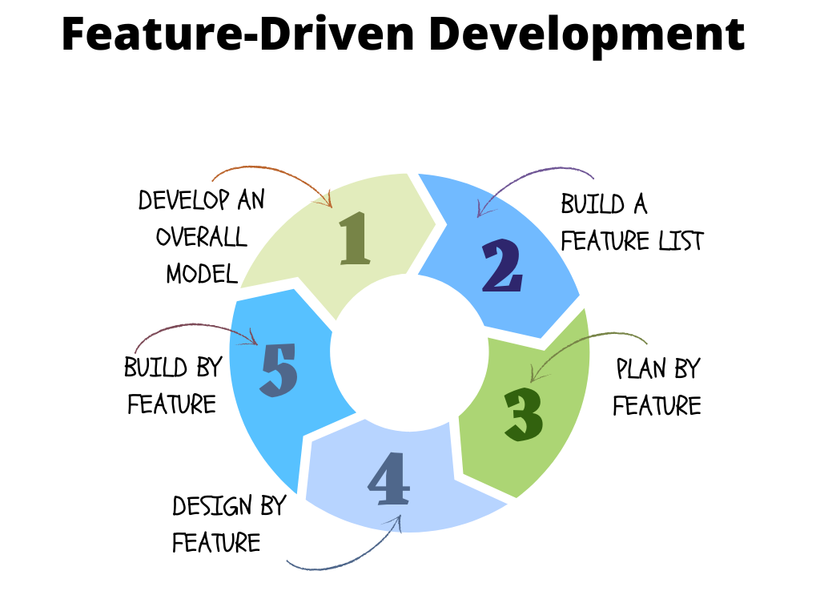

Figure 2: Feature-Driven Development (Mirzoyan, 2023)

Scrum is a framework for agile development that emphasizes incremental and iterative product creation. It places a strong emphasis on cooperation, adaptability, and ongoing progress. Scrum is a set of standardized roles, activities, deliverables, and guidelines that direct the development process. (nimble, 2023) Scrum is essential for a mobile application like ours because it enables us to embrace an iterative and incremental development approach. By working in short sprints, we can deliver valuable features and functionality faster. The regular feedback loops and collaboration within the scrum framework ensure that the application aligns closely with user needs and preferences, leading to a more effective solution. Scrum’s flexibility allows for us to adapt to changing requirements and incorporate user feedback, ultimately resulting in a high-quality mobile application that solves our problem (reducing food waste). (Peek, 2023)

Figure 3: Scrum Framework

Agile development processes are also commonly used in mobile application development, which involve iterative cycles of design, development, and testing. This approach allows developers to respond quickly to feedback and make changes to the application’s design and functionality based on user needs and preferences. Agile development processes can be particularly effective for a mobile application such as ours, as it allows developers to respond to the evolving needs of users and ensure that the application is meeting its intended purpose of reducing food waste (Esferasoft Solutions, 2021).

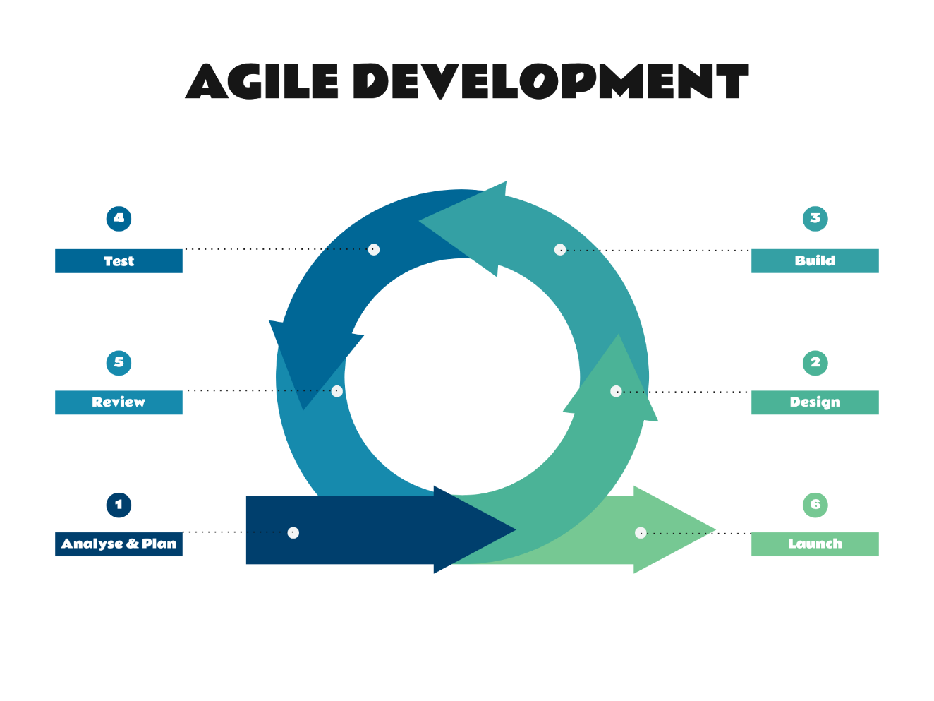

Figure 4: The Agile Development Process (Doherty, A., 2018)

In terms of critiques of these methodologies, one potential issue is that they can be time-consuming and resource intensive, particularly for smaller development teams or those with limited budgets. Additionally, user research and feature-driven development can be challenging to conduct effectively, particularly if the target user group is diverse or difficult to recruit for research studies. However, these methodologies are generally considered to be essential for effectively developing a mobile application. This is important for a mobile application like ours that is designed to meet a specific need and requires a deep understanding of its users’ motivations and behaviours.

## Conclusion

This literature review highlights the pressing issue of food wastage and the potential of mobile food-saver applications to address it. By providing consumers with a tool to reduce food wastage and save money, this mobile application has the potential to make a significant impact on the economic, environmental, and societal implications of food wastage.

This review combines the existing research on mobile food-saver applications and their impact on reducing food wastage, as well as the features and effectiveness of various applications in different contexts.

The findings suggest that mobile food-saver applications are a promising solution to reducing food waste, however, there is still much to be learned about when it comes to their effectiveness and impact in different contexts.

Overall, this review contributes to the growing body of knowledge on reducing food wastage and it provides insights for further research and development on mobile food-saver applications to address this issue.

# References

Fig.1. Hall, R., 2018. *How To Prototype A Mobile App And Leave A Lasting Impression On Investors - MindSea*. [Online] MindSea. Available at: https://mindsea.com/how-to-prototype-a-mobile-app/ [Accessed 15 April 2023].

Fig.2. Hall, R., 2018. *How To Prototype A Mobile App And Leave A Lasting Impression On Investors - MindSea*. [Online] MindSea. Available at: https://mindsea.com/how-to-prototype-a-mobile-app/ [Accessed 15 April 2023].

Fig.3. Hrzenjak, B., 2022. *Mobile app usability testing: a quick guide*. [Online] Available at: https://www.shakebugs.com/blog/mobile-app-usability-testing/ [Accessed 15 April 2023].

Fig.4. Doherty, A., 2018. *Agile Development at Primetics*. [Online] Primetics. Available at: https://primetics.co.uk/agile-development-at-primetics/ [Accessed 16 April 2023].

Anderson, J. & Poole, M., 2015. *Assignment and Thesis Writing. South African 4th Edition*. Juta.

Android Developers, 2018. *Android Developers*. [Online] Android Developers. Available at: https://developer.android.com/ [Accessed 14 April 2023].

Brainhub, 2023. *What is app prototyping?.* [Online]   
Available at: https://brainhub.eu/library/how-to-prototype-app-as-non-designer#:~:text=App%20prototyping%20is%20a%20form,the%20feasibility%20of%20a%20product.

E, M., 2023. *Which User Research Method Is Best for Mobile Apps?.* [Online]   
Available at: https://blog.getenjoyhq.com/which-user-research-method-is-best-for-mobile-apps/

go, T. g. t., 2023. *toogoodtogo.* [Online]   
Available at: https://www.toogoodtogo.com/

INSIGHT, O., 2023. *A step-by-step guide on how to conduct user research for different phases of your mobile app development.* [Online]   
Available at: https://www.orbitumlabs.com/blog/user-research

Ling, K., 2020. *Feature Driven Development (FDD).* [Online]   
Available at: https://www.productplan.com/glossary/feature-driven-development/  
[Accessed 24 6 2023].

lovefoodhatewaste., 2023. *lovefoodhatewaste..* [Online]   
Available at: https://www.lovefoodhatewaste.com/

Mirzoyan, V., 2023. *Why should you use a feature-driven development?.* [Online]   
Available at: https://aist.global/en/use-a-feature-driven-development  
[Accessed 24 6 2023].

nimble, 2023. What Is Scrum Methodology? & Scrum Project Management. *nimble,* 1(1), pp. 3-4.

olio, 2023. *olio.* [Online]   
Available at: https://olioex.com/

Peek, S., 2023. *What Is Agile Scrum Methodology?.* [Online]   
Available at: https://www.businessnewsdaily.com/4987-what-is-agile-scrum-methodology.html  
[Accessed 24 6 2023].

Salins, M., 2022. An Extensive Analysis of Understanding Consumer Intention towards Reduction of Food Waste. *Research Gate,* p. 12.

‌